
COMSATS University Islamabad,
Abbottabad Campus
SOFTWARE REQUIREMENTS SPECIFICATION
(SRS DOCUMENT)
for
<PROJECT NAME>
Version 1.0
By
Hashim Khan FA22-BSE-137
Ali Usman Tajik FA22-BSE-134

Supervisor
Ma’am Sana Malik

Bachelor of Science in Computer Science (2022-2026)

Table Of Contents
1. Introduction 5
1.1 Purpose 5
1.2 Scope 5
2. Overall Description 5
2.1 Product Perspective 5
2.2 Operating Environment 7
2.3 Design and Implementation Constraints 8
3. Requirement Identifying Techniques 9
3.1 Use Case Diagram 10
3.2 Use Case Descriptions 13
4. Functional Requirements 24
5. Non-Functional Requirements 35
5.1 Usability Requirements 35
5.2 Reliability Requirements 35
5.3 Performance Requirements 35
7. Project Gantt Chart 36
8. References 37

Revision History
Name | Date | Reason for changes | Version

Application Evaluation History

Comments (by committee)  *include the ones given at scope time both in doc and presentation | Action Taken

Supervised by
<Supervisor’s Name>
Signature___________

1. Introduction
TrekPal is a smart travel management platform designed to simplify and enhance the trip-planning experience for travelers, travel agencies, and administrators. The system provides a unified ecosystem where travelers can search and book verified hotels and transport, create trip requests, receive agency bids, join group trips, and communicate through real-time chat. Travel Agencies can manage their hotels, vehicles, bookings, and respond to traveler requests, while Admins ensure platform safety through verification and moderation tools.
TrekPal aims to make travel safer, more organized, and more accessible by combining booking, trip planning, group coordination, and verified service providers in a single application. Built with Flutter, React, Node.js, and firebase, the platform emphasizes usability, reliability, and scalability to support a growing travel community.

1.1 Purpose
The purpose of this Software Requirements Specification (SRS) is to formally describe the functional and non-functional requirements of TrekPal, a hybrid travel-planning platform consisting of:
- Mobile application for users
- Web portal for hotel owners
- Admin dashboard for system administrators
This document establishes a clear understanding of system objectives, features, constraints, and interactions among stakeholders including developers, users, hotel owners, and administrators.

1.2 Scope
TrekPal is a unified travel management platform designed to connect Travelers, Travel Agencies, and Administrators through a single ecosystem. The system provides verified hotel discovery, transport booking, trip planning, group travel management, and a competitive bidding system for

2. Overall Description

2.1 Product Perspective
TrekPal is a multi-tier, service-oriented ecosystem designed to streamline travel planning by connecting Travelers, Travel Agencies, and Administrators within a unified digital platform. The system introduces a consolidated business entity called the Travel Agency, which replaces separate Hotel Owner and Transport Owner roles

1. Mobile Application (Flutter)
The mobile app serves as the primary interface for end-users (Travelers). It enables them to:
- Register and complete identity verification
- Search and book hotels managed by Travel Agencies
- Search and book transport options (cars, jeeps, vans, coasters, etc.)
- Create Trip Requests, defining trip preferences, destination, dates, and budget
- Receive and compare bids submitted by Travel Agencies
- Accept a bid, which triggers automatic generation of hotel/transport bookings
- Join or create group trips
- Communicate using real-time chat
- Submit reviews and ratings
- Receive push notifications for bid submissions, booking updates, and trip activity
This subsystem interacts heavily with the backend via REST APIs, Firebase Authentication, and WebSocket services.
2. Travel Agency Web Portal (React.js)
The Travel Agency represents a unified business entity that manages all commercial assets and services.
A single Travel Agency account can:
- Register on the platform and submit verification documents
- Add and manage multiple hotels, including rooms, pricing, food menus, and media
- Add and manage multiple transport vehicles, including capacity, availability, pricing, and driver information
- View all incoming Traveler Trip Requests
- Submit customized bids containing combined hotel + vehicle + package offerings
- Manage bookings that result from accepted bids
- Create optional tour packages
- Use dashboards for bookings, revenue, and agency performance
This portal replaces the earlier Hotel Owner and Transport Owner portals and consolidates them into a single, more powerful operational dashboard.

3. Admin Web Portal (React.js)
The admin dashboard provides system-wide oversight and quality control. Admins can:
- Approve or reject Travel Agency registrations
- Approve or reject hotels and vehicles submitted by agencies
- Approve traveler identity verification
- Monitor Trip Requests and bids for fairness and compliance
- Suspend or block suspicious activity (travelers or agencies)
- Manage content moderation (reviews, misuse reports)
- View real-time analytics and platform statistics

2.2 Operating Environment
TrekPal must operate under the following environmental conditions:

OE-1 Mobile Application Environment
- Flutter SDK 3.22+
- Android 10+
- Device must support internet connectivity
- Minimum RAM required: 4 GB

OE-2 Web Portal Requirements
- Compatible web browsers:
  - Chrome (latest)
  - Firefox (latest)
  - Microsoft Edge
- React.js 18 environment
- Modern desktop or laptop

OE-3 Backend Environment
- Node.js v20
- PostgreSQL 7.0
- Firebase SDK 2025

OE-4 Network Requirements
- Stable internet connection for real-time:
  - Booking updates
  - Group chat
  - Trip coordination
- Minimum recommended speed: 1 Mbps

2.3 Design and Implementation Constraints

CO-1: Dependency on Internet
TrekPal is an online-first application. All modules booking, chat, trip groups require network connectivity.

CO-2: Cross-Platform Consistency
Both mobile and web portals must share:
- API structure
- Design consistency
- Data models

CO-3: Device Limitations
Low-end devices may struggle with:
- Real-time chats
- Map rendering
- High-quality image loading

CO-4: No Payment Integration
Booking confirmation will be offline or cash-based.

CO-5: Third-Party API Restrictions
Google Maps API credits and limits may affect:
- Search radius
- Map load count
- Live route generation

3. Requirement Identifying Techniques
The requirements for TrekPal are primarily identified using:
- Use Case Modelling
- Stakeholder interviews (travelers, hotel owners)
- Analysis of competitor applications (Airbnb, Booking.com, TripAdvisor)
- Survey-based requirement gathering
Use cases provide a clear and structured way to capture the system’s functional requirements.

3.1 Use Case Diagram
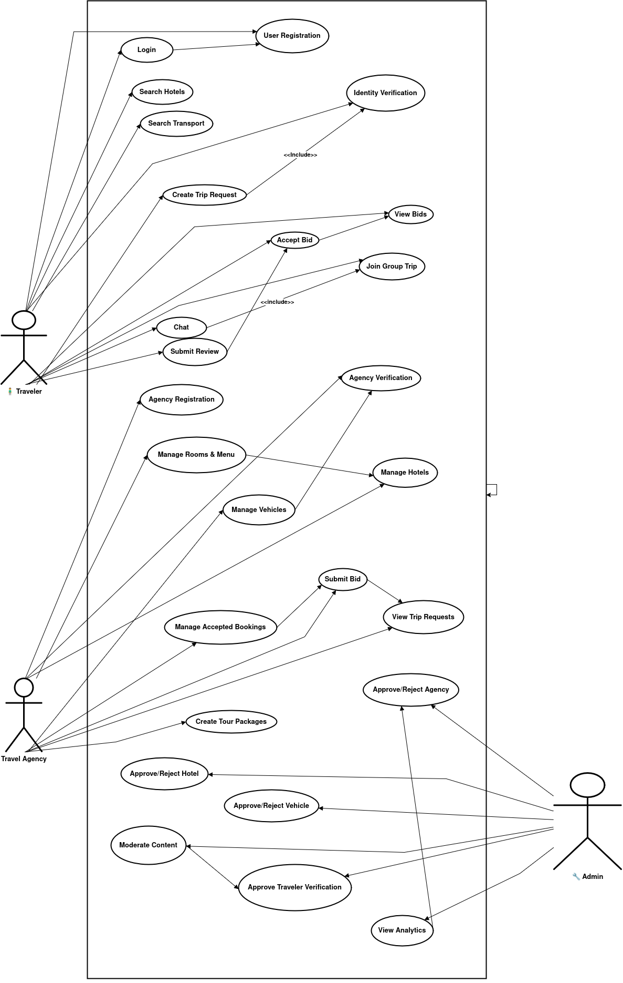
Actors

1. Traveler (User)
The primary end-user who:
- Creates Trip Requests
- Receives and compares bids
- Accepts bids which generate bookings
- Searches hotels and transport
- Books accommodations & vehicles
- Uses chat and group travel features
- Submits reviews

2. Travel Agency (Unified Business Actor)
A verified business account that:
- Manages hotels, rooms, menus
- Manages transport vehicles
- Views Trip Requests
- Submits bids to travelers
- Manages bookings from accepted bids
- Creates optional tour packages

3. Admin
Platform supervisor who:
- Verifies travelers & agencies
- Approves/rejects hotels and vehicles
- Moderates content
- Manages users
- Views system analytics

Use Cases Included in TrekPal
Traveler Use Cases
- UC-1 Register Account
- UC-2 Complete Verification
- UC-3 Search Hotels
- UC-4 Search Transport
- UC-5 Create Trip Request
- UC-6 View Bids
- UC-7 Accept Bid
- UC-8 Join Group Trip
- UC-9 Chat with Group Members
- UC-10 Submit Review
Travel Agency Use Cases
- UC-AG-01 Register Travel Agency
- UC-AG-02 Submit Agency Verification Documents
- UC-AG-03 Manage Hotels
- UC-AG-04 Manage Rooms & Menus
- UC-AG-05 Manage Vehicles
- UC-AG-06 View Trip Requests
- UC-AG-07 Submit Bid
- UC-AG-08 Manage Accepted Bookings
- UC-AG-09 Create Tour Packages (optional)

Admin Use Cases
- UC-ADM-01 Approve/Reject Travel Agency registration
- UC-ADM-02 Approve/Reject hotels submitted by agencies
- UC-ADM-03 Approve/Reject vehicles submitted by agencies
- UC-ADM-04 Approve traveler verification
- UC-ADM-05 Block/Unblock travelers or agencies
- UC-ADM-06 View system analytics
- UC-ADM-07 Moderate reviews and flagged content

3.2 Use Case Descriptions

UC-1: User Registration

Field | Description
Use Case ID | UC-1
Use Case Name | User Registration
Actor | Traveler
Description | The traveler creates a new account using email, phone number, or Google Sign-In.
Trigger | Traveler selects “Sign Up”.
Preconditions | None
Postconditions | A traveler account is created and can log in.
Main Flow | 1. Traveler enters required information.2. System validates inputs.3. System creates account.4. System sends confirmation/verification.
Alternative Flows | AF-1: Invalid input > system displays error.AF-2: Email already used > system requests different email.
Business Rules | BR-1: Email must be unique.

UC-2: Verification

Field | Description
Use Case ID | UC-2
Use Case Name | Identity Verification
Actor | Traveler
Description | Traveler uploads CNIC images to complete verification.
Trigger | Traveler selects “Verify Identity”.
Preconditions | Traveler is logged in.
Postconditions | Verification request submitted to Admin.
Main Flow | 1. Traveler uploads CNIC front/back.2. System stores documents.3. System notifies Admin.
Alternative Flows | AF-1: Upload failure > system requests retry.
Business Rules | BR-2: Verified identity required for certain booking operations.

UC-3: Hotel Search

Field | Description
Use Case ID | UC-3
Use Case Name | Search Hotels
Actor | Traveler
Description | Traveler searches available hotels.
Trigger | Traveler enters destination or opens hotel search.
Preconditions | Internet connection available.
Postconditions | List of matching hotels displayed.
Main Flow | 1. Traveler enters search query/filters.2. System retrieves approved hotels.3. System displays searchable list.
Alternative Flows | AF-1: No hotels found > “No results” message.
Business Rules | BR-3: Only verified agency hotels may appear in search.

UC-4: Search Transport

Field | Description
Use Case ID | UC-4
Use Case Name | Search Transport
Actor | Traveler
Description | Traveler searches available vehicles.
Trigger | Traveler opens Transport section.
Preconditions | Internet connection available.
Postconditions | Matching vehicles displayed.
Main Flow | 1. Traveler enters route/date.2. System retrieves vehicles.3. System displays list.
Alternative Flows | AF-1: No transport found.
Business Rules | BR-4: Vehicles must be approved by Admin.

UC-5: Create Trip Group

Field | Description
Use Case ID | UC-5
Use Case Name | Create Trip Request
Actor | Traveler
Description | Traveler creates a Trip Request specifying destination, dates, pax, and preferences.
Trigger | Traveler selects “Create Trip Request”.
Preconditions | Traveler identity verified.
Postconditions | Trip Request visible to Travel Agencies.
Main Flow | 1. Traveler enters details.2. System validates and saves.3. System notifies agencies.
Alternative Flows | AF-1: Invalid data.AF-2: Canceled before submission.
Business Rules | BR-5: Requests expire after a defined validity period.

UC-6: View Bids

Field | Description
Use Case ID | UC-6
Use Case Name | View Bids
Actor | Traveler
Description | Traveler views all bids submitted by agencies.
Trigger | Traveler opens Trip Request details.
Preconditions | Bids exist for the request.
Postconditions | Bids displayed and can be compared.
Main Flow | 1. Traveler opens request.2. System displays active bids.
Alternative Flows | AF-1: No bids yet.
Business Rules | BR-6: Only active bids shown.

UC-7: Accept Bid

Field | Description
Use Case ID | UC-7
Use Case Name | Accept Bid
Actor | Traveler
Description | Traveler accepts a bid, resulting in bookings.
Trigger | User clicks “Accept Bid.”
Preconditions | Trip Request active; bid available.
Postconditions | Bookings generated; agency notified.
Main Flow | 1. Traveler selects bid.2. System marks it accepted.3. System creates associated bookings.4. Notification sent to agency.
Alternative Flows | AF-1: Bid expired.AF-2: Bid withdrawn before acceptance.
Business Rules | BR-7: Accepted bids create binding bookings.

UC-8: Join Group Trip

Field | Description
Use Case ID | UC-8
Use Case Name | Join Group Trip
Actor | Traveler
Description | Traveler joins an existing group trip.
Trigger | Traveler taps “Join”.
Preconditions | Group has available seats.
Postconditions | User added to group.
Main Flow | 1. Join request sent.2. Group owner approves (or auto-approve).3. Traveler added.
Alternative Flows | AF-1: Group full.
Business Rules | BR-8: Some groups require verified users.

UC-9: Group Chat

Field | Description
Use Case ID | UC-9
Use Case Name | Group Chat
Actor | Traveler
Description | Travelers communicate in group chat.
Trigger | Traveler opens chat.
Preconditions | Traveler is trip group member.
Postconditions | Message delivered and stored.
Main Flow | 1. Traveler sends message.2. System broadcasts via WebSocket/FCM.3. Message stored.
Alternative Flows | AF-1: User offline > queued message.
Business Rules | BR-9: Message retention policy applies.

UC-10: Submit Review

Field | Description
Use Case ID | UC-10
Use Case Name | Submit Review
Actor | Traveler
Description | Traveler submits a review after a completed booking.
Trigger | Traveler selects “Write Review”.
Preconditions | Relevant hotel/vehicle booking completed.
Postconditions | Review published or held for moderation.
Main Flow | 1. Traveler writes review.2. System validates and saves.3. Review becomes visible.
Alternative Flows | AF-1: Violating content > flagged.
Business Rules | BR-10: One review per booking allowed.

Travel Agency Use Cases
UC-AG-01: Agency Registration
Field | Description
Use Case ID | UC-AG-01
Use Case Name | Agency Registration
Actor | Travel Agency
Description | The agency registers with business details and credentials.
Trigger | Agency selects “Register”.
Preconditions | None
Postconditions | Agency account created in pending-verification state.
Main Flow | 1. Agency enters details.2. Uploads business documents.3. System saves record.4. Admin notified.
Alternative Flows | AF-1: Missing documents.
Business Rules | BR-A1: Valid business documentation required.

UC-AG-02: Manage Hotels
Field | Description
Use Case ID | UC-AG-02
Use Case Name | Manage Hotels
Actor | Travel Agency
Description | Agency adds and updates hotels in its portfolio.
Trigger | Agency opens hotel management.
Preconditions | Agency verified.
Postconditions | Hotels stored (pending or approved).
Main Flow | 1. Add/edit hotel details.2. Upload images.3. Save listing.4. Admin approval if required.
Alternative Flows | AF-1: Missing mandatory fields.
Business Rules | BR-A2: Hotels require admin approval.

UC-AG-03: Manage Rooms & Menu
Field | Description
Use Case ID | UC-AG-03
Use Case Name | Manage Rooms & Menu
Actor | Travel Agency
Description | Add/edit/delete rooms and food menu.
Trigger | Agency opens room/menu section.
Preconditions | Agency owns hotel.
Postconditions | Room/menu data updated.
Main Flow | 1. Select hotel.2. Add/edit rooms/menus.3. Save updates.
Alternative Flows | AF-1: Invalid pricing or parameters.
Business Rules | BR-A3: Certain changes may require admin review.

UC-AG-04: Manage Vehicles
Field | Description
Use Case ID | UC-AG-04
Use Case Name | Manage Vehicles
Actor | Travel Agency
Description | Agency adds and updates transport vehicles.
Trigger | Agency opens vehicle section.
Preconditions | Agency verified.
Postconditions | Vehicle saved (pending/approved).
Main Flow | 1. Enter vehicle details.2. Upload documents.3. Save.4. Admin approval required.
Alternative Flows | AF-1: Missing registration documents.
Business Rules | BR-A4: Only approved vehicles are displayed.

UC-AG-05: View Trip Requests
Field | Description
Use Case ID | UC-AG-05
Use Case Name | View Trip Requests
Actor | Travel Agency
Description | Agency views Trip Requests posted by travelers.
Trigger | Agency opens Trip Request marketplace.
Preconditions | Active agency account.
Postconditions | Requests displayed.
Main Flow | 1. Agency opens marketplace.2. Filters requests.3. Views details.
Alternative Flows | AF-1: No matching requests.
Business Rules | BR-A5: Only requests within agency’s service area appear.

UC-AG-06: Submit Bid
Field | Description
Use Case ID | UC-AG-06
Use Case Name | Submit Bid
Actor | Travel Agency
Description | Agency submits a bid for a Trip Request.
Trigger | Agency selects “Place Bid”.
Preconditions | Trip Request active.
Postconditions | Bid stored and visible to traveler.
Main Flow | 1. Agency fills bid details.2. System validates.3. Bid posted.
Alternative Flows | AF-1: Withdraw bid before acceptance.AF-2: Update bid.
Business Rules | BR-A6: Bids must reference agency-owned assets.

UC-AG-07: Manage Accepted Bookings

Field | Description
Use Case ID | UC-AG-07
Use Case Name | Manage Accepted Bookings
Actor | Travel Agency
Description | Agency manages bookings created from accepted bids.
Trigger | Bid accepted by traveler.
Preconditions | Booking exists.
Postconditions | Booking status updated.
Main Flow | 1. Agency views booking list.2. Confirms hotel/vehicle reservations.3. Updates status.
Alternative Flows | AF-1: Cancel booking (per policy).
Business Rules | BR-A7: Booking updates must notify travelers.

Admin Use Cases

UC-ADM-01: Approve/Reject Agency Registration
Field | Description
Use Case ID | UC-ADM-01
Use Case Name | Approve/Reject Agency Registration
Actor | Admin
Description | Admin verifies agency documents and approves or rejects.
Trigger | Admin opens pending agencies.
Preconditions | Agency submitted registration.
Postconditions | Agency marked approved or rejected.
Main Flow | 1. Admin inspects documents.2. Approves or rejects.3. System notifies agency.
Alternative Flows | AF-1: Request additional documents.
Business Rules | BR-ADM1: Only approved agencies may operate.

UC-ADM-02: Approve/Reject Hotel
Field | Description
Use Case ID | UC-ADM-02
Use Case Name | Approve/Reject Hotel
Actor | Admin
Description | Admin reviews hotel listings.
Trigger | Admin opens pending hotels.
Preconditions | Hotel submitted by an agency.
Postconditions | Hotel status updated.
Main Flow | Review > Approve/Reject > Notify agency
Business Rules | BR-ADM2: Unapproved hotels hidden in search.

UC-ADM-03: Approve/Reject Vehicle
Field | Description
Use Case ID | UC-ADM-03
Use Case Name | Approve/Reject Vehicle
Actor | Admin
Description | Admin validates vehicle details.
Trigger | Admin opens pending vehicles.
Preconditions | Vehicle submitted by agency.
Postconditions | Vehicle approved or rejected.

UC-ADM-04: Approve Traveler Verification
Field | Description
Use Case ID | UC-ADM-04
Use Case Name | Approve Traveler Verification
Actor | Admin
Description | Admin verifies traveler identity documents.

UC-ADM-05: Moderate Content
Field | Description
Use Case ID | UC-ADM-05
Use Case Name | Moderate Content
Actor | Admin
Description | Admin handles flagged reviews, posts, or chats.

UC-ADM-06: View Analytics
Field | Description
Use Case ID | UC-ADM-06
Use Case Name | View Analytics
Actor | Admin
Description | Admin views system metrics and reports.

UC-ADM-07: Block/Unblock User or Agency
Field | Description
Use Case ID | UC-ADM-07
Use Case Name | Block/Unblock User or Agency
Actor | Admin
Description | Admin suspends or reinstates accounts.

4. Functional Requirements

Admin Portal Functional Requirements

FR-USER-01 — User Registration
Field | Description
Identifier | FR-USER-01
Title | User Registration
Requirement | The system shall allow travelers to create an account using email, phone number, or Google Sign-In.
Source | Traveler Use Cases (UC-1)
Rationale | Required for all personalized features.
Business Rules | Email/phone must be unique.
Dependencies | None
Priority | High

FR-USER-02 — Traveler Login

Field | Description
Identifier | FR-USER-02
Title | Traveler Login
Requirement | The system shall allow travelers to log in securely through Firebase Authentication.
Source | UC-1
Rationale | Enables authenticated access.
Business Rules | Tokens must be refreshed securely.
Dependencies | FR-USER-01
Priority | High

FR-USER-03 — Identity Verification

Field | Description
Identifier | FR-USER-03
Title | Identity Verification
Requirement | Travelers shall upload CNIC images for identity verification.
Source | UC-2
Rationale | Enhances user safety and compliance.
Business Rules | Verified users may access restricted features (e.g., bidding acceptance).
Dependencies | FR-USER-02
Priority | High

FR-USER-04 — Search Hotels

Field | Description
Identifier | FR-USER-04
Title | Search Hotels
Requirement | The system shall allow travelers to search hotels using filters such as location, rating, room type, and price.
Source | UC-3
Rationale | Core functionality of travel planning.
Business Rules | Only approved agency hotels appear in results.
Dependencies | Agency hotel data
Priority | High

FR-USER-05 — Search Transport

Field | Description
Identifier | FR-USER-05
Title | Search Transport
Requirement | The system shall allow travelers to search vehicles offered by Travel Agencies based on route, capacity, availability, and price.
Source | UC-4
Rationale | Provides travel mobility options.
Business Rules | Only approved vehicles appear.
Dependencies | Agency transport data
Priority | High

FR-USER-06 — Create Trip Request

Field | Description
Identifier | FR-USER-06
Title | Create Trip Request
Requirement | The system shall allow travelers to create Trip Requests including destination, dates, passengers, preferences, and budget.
Source | UC-5
Rationale | Enables agency bidding workflow.
Business Rules | Trip Requests must expire after a validity period.
Dependencies | FR-USER-03
Priority | High

FR-USER-07 — View Bids

Field | Description
Identifier | FR-USER-07
Title | View Bids
Requirement | The system shall display all bids submitted by agencies for a Trip Request.
Source | UC-6
Rationale | Traveler must compare offers.
Business Rules | Only active bids shown.
Dependencies | FR-AGENCY-07
Priority | High

FR-USER-08 — Accept Bid

Field | Description
Identifier | FR-USER-08
Title | Accept Bid
Requirement | The system shall allow the traveler to accept one bid, after which hotel and transport bookings are automatically created.
Source | UC-7
Rationale | Converts trip planning into confirmed bookings.
Business Rules | Accepted bid becomes binding according to platform policy.
Dependencies | FR-USER-06, FR-AGENCY-07
Priority | Critical

FR-USER-09 — Join Group Trip

Field | Description
Identifier | FR-USER-09
Title | Join Group Trip
Requirement | The system shall allow travelers to join group trips based on availability.
Source | UC-8
Rationale | Supports social travel features.
Business Rules | Some groups may require verified users.
Dependencies | Group module
Priority | Medium

FR-USER-10 — Submit Review

Field | Description
Identifier | FR-USER-10
Title | Submit Review
Requirement | The system shall allow travelers to submit reviews for hotels, vehicles, or agencies after trip completion.
Source | UC-10
Rationale | Enhances transparency and quality assurance.
Business Rules | One review per booking.
Dependencies | Completed booking
Priority | Medium

Travel Agency Functional Requirements

FR-AGENCY-01 — Agency Registration

Field | Description
Identifier | FR-AGENCY-01
Title | Agency Registration
Requirement | Agencies shall be able to register a business account by providing details and documents.
Source | UC-AG-01
Rationale | Required for agencies to participate.
Dependencies | None
Priority | High

FR-AGENCY-02 — Agency Verification

Field | Description
Identifier | FR-AGENCY-02
Title | Agency Verification
Requirement | Agencies shall upload business documents for admin approval.
Source | UC-AG-01 / UC-ADM-01
Rationale | Ensures platform trust & safety.
Dependencies | Admin module
Priority | High

FR-AGENCY-03 — Manage Hotels

Field | Description
Identifier | FR-AGENCY-03
Title | Manage Hotels
Requirement | Agencies shall add, update, and delete hotels.
Source | UC-AG-02
Rationale | Core service offering.
Business Rules | Hotels require admin approval before appearing publicly.
Dependencies | FR-AGENCY-02
Priority | High

FR-AGENCY-04 — Manage Rooms & Food Menus

Field | Description
Identifier | FR-AGENCY-04
Title | Manage Rooms & Menus
Requirement | Agencies shall manage room details, prices, availability, and food menus.
Source | UC-AG-03
Rationale | Required for accurate hotel listings.
Dependencies | FR-AGENCY-03
Priority | High

FR-AGENCY-05 — Manage Vehicles

Field | Description
Identifier | FR-AGENCY-05
Title | Manage Vehicles
Requirement | Agencies shall add and manage transport vehicles.
Source | UC-AG-04
Rationale | Provides transport services.
Business Rules | Vehicles require admin approval.
Dependencies | FR-AGENCY-02
Priority | High

FR-AGENCY-06 — Manage Vehicle Availability

Field | Description
Identifier | FR-AGENCY-06
Title | Manage Vehicle Availability
Requirement | Agencies shall define availability and pricing per date.
Source | UC-AG-04
Rationale | Enables accurate bookings & bidding.
Dependencies | FR-AGENCY-05
Priority | Medium

FR-AGENCY-07 — View Trip Requests

Field | Description
Identifier | FR-AGENCY-07
Title | View Trip Requests
Requirement | Agencies shall view active Trip Requests submitted by travelers.
Source | UC-AG-05
Rationale | Required for bidding process.
Dependencies | FR-USER-06
Priority | High

FR-AGENCY-08 — Submit Bid

Field | Description
Identifier | FR-AGENCY-08
Title | Submit Bid
Requirement | Agencies shall submit a bid including price, hotel, vehicle, and services.
Source | UC-AG-06
Rationale | Enables competitive marketplace.
Business Rules | Bids must reference agency-owned, approved assets.
Dependencies | FR-AGENCY-03, FR-AGENCY-05
Priority | Critical

FR-AGENCY-09 — Manage Accepted Bookings

Field | Description
Identifier | FR-AGENCY-09
Title | Manage Accepted Bookings
Requirement | Agencies shall manage bookings created from accepted bids.
Source | UC-AG-07
Rationale | Ensures fulfillment of hotel/transport services.
Dependencies | Accepted bid
Priority | High

FR-AGENCY-10 — Create Tour Packages

Field | Description
Identifier | FR-AGENCY-10
Title | Create Tour Packages
Requirement | Agencies shall create optional tour packages with itinerary and pricing.
Source | UC-AG-10
Rationale | Additional service offering.
Dependencies | FR-AGENCY-02
Priority | Medium

Admin Functional Requirements

FR-ADMIN-01 — Approve/Reject Agency Registration

Field | Description
Identifier | FR-ADMIN-01
Title | Approve/Reject Agency Registration
Requirement | Admin shall approve or reject Travel Agency registrations.
Source | UC-ADM-01
Rationale | Ensures only legitimate businesses operate.
Dependencies | FR-AGENCY-01
Priority | High

FR-ADMIN-02 — Approve/Reject Hotels

Field | Description
Identifier | FR-ADMIN-02
Title | Approve/Reject Hotels
Requirement | Admin shall review hotels submitted by agencies and approve or reject them.
Source | UC-ADM-02
Rationale | Ensures quality and trust.
Dependencies | FR-AGENCY-03
Priority | High

FR-ADMIN-03 — Approve/Reject Vehicles

Field | Description
Identifier | FR-ADMIN-03
Title | Approve/Reject Vehicles
Requirement | Admin shall verify all vehicle submissions.
Source | UC-ADM-03
Rationale | Ensures safe and verified transport options.
Dependencies | FR-AGENCY-05
Priority | High

FR-ADMIN-04 — Approve Traveler Verification

Field | Description
Identifier | FR-ADMIN-04
Title | Approve Traveler Verification
Requirement | Admin shall verify traveler identity documents.
Source | UC-ADM-04
Rationale | Increases user trust.
Priority | High

FR-ADMIN-05 — Content Moderation

Field | Description
Identifier | FR-ADMIN-05
Title | Moderate Content
Requirement | Admin shall review and manage reported reviews, chats, or posts.
Source | UC-ADM-05
Rationale | Ensures platform safety.
Priority | Medium

FR-ADMIN-06 — View Analytics

Field | Description
Identifier | FR-ADMIN-06
Title | View Analytics
Requirement | Admin shall view dashboards for bookings, trips, revenue, and system usage.
Source | UC-ADM-06
Rationale | Supports decision-making.
Priority | Medium

FR-ADMIN-07 — Block/Unblock Accounts

Field | Description
Identifier | FR-ADMIN-07
Title | Block/Unblock Accounts
Requirement | Admin shall be able to block or unblock travelers or agencies.
Source | UC-ADM-07
Rationale | Protects system integrity.
Priority | High

5. Non-Functional Requirements
Non-functional requirements describe the quality attributes of the TrekPal system.

5.1 Usability Requirements
NFR-USE-01 — Simple & Intuitive UI
The system shall provide a clean and easy-to-navigate interface on both mobile and web.
NFR-USE-02 — Clear Feedback
Users shall receive meaningful success/error messages.
NFR-USE-03 — Easy Onboarding
Registration and login shall be completed within a few simple steps.

5.2 Reliability Requirements
NFR-REL-01 — High Availability
The system shall maintain 99% uptime.
NFR-REL-02 — Prevent Double Booking
The system shall ensure no hotel room or vehicle can be double-booked.
NFR-REL-03 — Data Backup
Database backups shall occur at least once daily.

5.3 Performance Requirements
NFR-PERF-01 — Fast Response
Search results and main screens shall load within 2–3 seconds.
NFR-PERF-02 — Real-Time Chat
Chat messages shall deliver with a delay of less than 300 ms.
NFR-PERF-03 — Scalable User Load
The system shall support large numbers of active users without performance degradation.

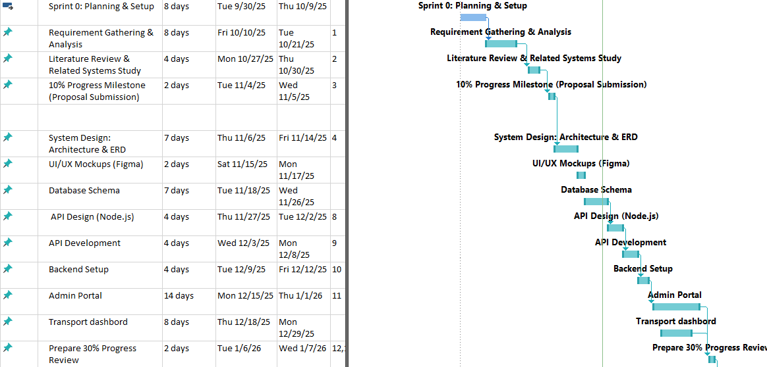
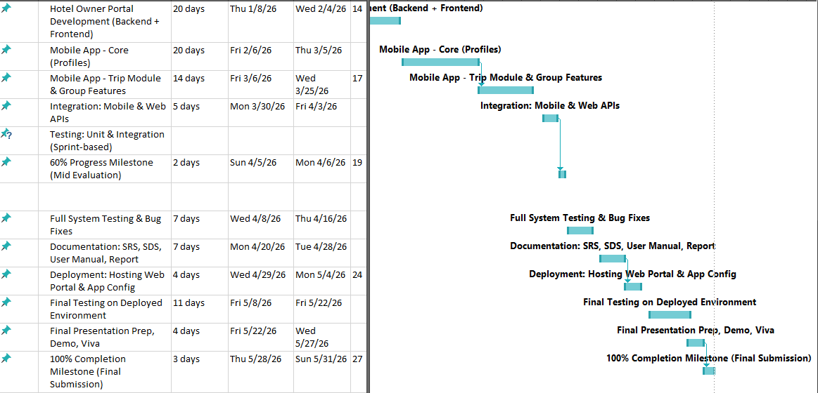
7. Project Gantt Chart

8. References
Sommerville, Ian. Software Engineering (10th Edition).
Pressman, R. S. Software Engineering: A Practitioner’s Approach.
Flutter Documentation https://flutter.dev
Firebase Documentation https://firebase.google.com
PostgreSQL Documentation https://postgresql.org
Google Maps API https://developers.google.com/maps
Node.js Official Documentation https://nodejs.org
COMSATS SRS Template Guidelines
TrekPal Feasibility Document (Uploaded by student) Used for scope & modules

